

**MINI PROJECT**

**On**

***PASSWORD AND LOGIN MANAGEMENT SYSTEM***

Submitted by : **Vikram Anandnarayan Hegde**

SFid : **105182**

Email id : [vikramhegde93@gmail.com](mailto:vikramhegde93@gmail.com)

**Table Of Contents:**

|  |  |  |
| --- | --- | --- |
| **Sl.No** | **Topic** | **Page no.** |
| 1. | Problem Statement | 3 |
| 2. | Description | 3 |
| 3. | Requirements | 4 |
| 4. | UML Diagram | 5 |
| 5. | Architecture | 6 |
| 6. | Test Plan and Test Cases | 7 |
| 7. | Conclusion | 8 |
| 8. | Reference | 8 |

**List of Figures**

|  |  |  |
| --- | --- | --- |
| **Sl.No.** | **Topic** | **Page no.** |
| 1. | Figure no. 4.1 | 5 |
| 2. | Figure no. 5.1 | 6 |

**List of Tables**

|  |  |  |
| --- | --- | --- |
| **SL.No.** | **Topic** | **Page no.** |
| 1. | Table no. 6.1 | 7 |

# Problem Statement

Lots of users do not keep their login credentials and passwords strong in websites, social media and many other platforms. Without using proper password or strong password leads to hacking and misuse of thier account in mentioned platforms. So this software helps users to maintain proper, strong and secure passwords in websites and other platforms. It also helps the users to be safe and secure while using this system. It is called as “**Password and login management system**”

## Description

Password and login management is for the user who want have strong and secure accounts in any platforms. The user will be updated until his password meets conditions. This system mainly has one section :

* Registration section

Here every person who try to register his passwords will going on getting about how to keep the password strong. Until the system verify and tell your password is good enough a user cannot create or choose his password.

In this system password should be combination of multiple keys which can be known by user at the time of password verification. This helps user to maintain strong password.

**Main modules:**

1. Registration
2. Entering username
3. Enter password
4. Check password requirements
5. Confirm password
6. Quit

## Requirements

1. **Project specification**

* Complier : GNU GCC COMPILER
* Editor : Code::Blocks IDE v20.03

1. **Operating System:**

* Preferably Windows OS
* Ubuntu
* Mac

1. **Programming Language:**

● C language

1. **Functional Requirements:**

* **Registration :** It allows user to register their account and helps to get secure password.
* **Username :** The user should enter his username and proceed to the next step.
* **Enter password :** Allows user to keep or set password to users account.
* **Checking password :** This function is performed by the system which tells the user to choose valid password. If requirements passes then user is good to go.
* **Confirm password:** To check whether the user has correctly types his password or not. If entered password and confirm password matches, password is accepted.
* **Quit :** Quit form the registration panel or module.

1. **UML Diagram**​

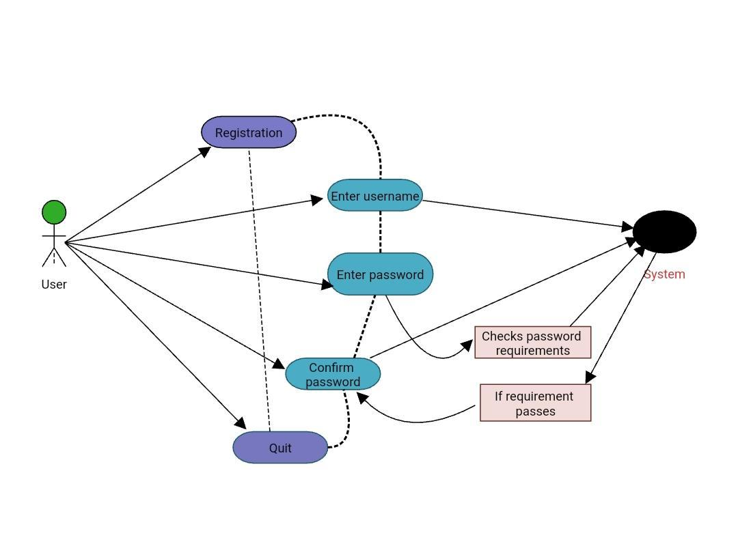

**Figure no. 4.1**

# Architecture

**Architecture or flow chart of system**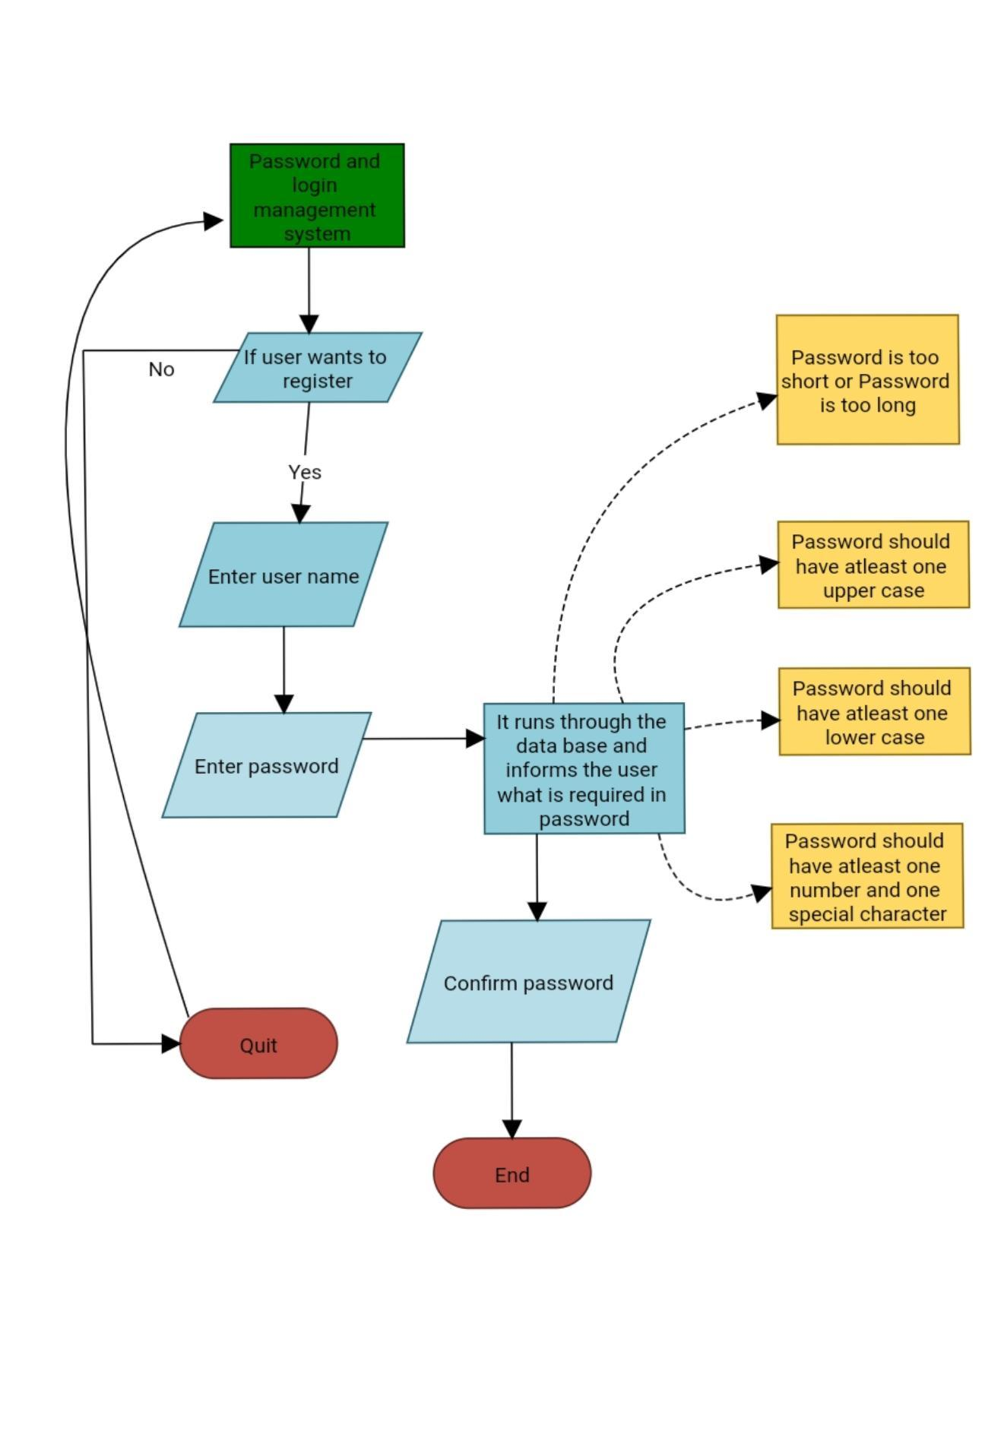

**Figure no. 5.1**

# Test Plan​ And Test Cases

|  |  |  |  |
| --- | --- | --- | --- |
| **S.No** | **Objective** | **Expected Result** | **Actual Result** |
| 1. | To check if the program displays all options  correctly | All given options are to be displayed with serial number | All options are displayed correctly in the given order |
| 2. | To check if the user can  Enter the password | Users have to enter the password | Password should be able to entered by user. |
| 3. | To check if the users password meets the requirements | The password should meet the system requirements set by developer | Until password is accepted by system user will notified to choose different password |
| 4. | To check whether user knows his password by confirming. | Password should match entered password and confirm password. | Enter Password and Confirm password has been matched |
| 5. | To verify that quit operation is working properly | If user opted quit then program should quit | Program quits when users want to quit |

**Table no. 6.1**

# Conclusion

The main goal of password and login system is to have strong and secure accounts in different platforms by having an strong password with combinations of numbers alphabets and special characters. Having a strong password is like having and secure account in any registration platform. By using this system every user will keep his password strong and this will lead to low level risk of security issues in websites etc. By using this system in websites or in different platforms users will have complete trust to create account as it is secure. Here by this is to conclude that Passwords and login management system is a good project for those who really wants a secure accounts in websites, social media or some other platforms.

1. **References**

Code::blocks :

* <http://www.codeblocks.org/>

C language :

* <https://archive.codeplex.com/?p=turboc>
* <https://sololearn.com/Play/C>

Wikipedia :

* <https://en.m.wikipedia.org/wiki/Password>

Other useful links:

* <https://www.lucidchart.com/pages/uml-class-diagram>
* <https://www.sciencedirect.com/topics/computer-science/weak-password#:~:text=Weak%20passwords%20can%20be%20guessable,needed%20to%20be%20stored%20properly>
* <https://www.includehelp.com/c-programming-questions/what-is-makefile.aspx#:~:text=Makefile%20is%20a%20tool%20to,to%20remove%20object%2C%20binary%20files>

**Thank you**